# CS 255 System Design Document Template

## UML Diagrams

### UML Use Case Diagram

### UML Activity Diagrams

*[You were asked to choose* ***two*** *use cases and create* ***two*** *activity diagrams, one for each use case. Please insert* ***both*** *of your activity diagrams here. Check to make sure that you included appropriate components and symbols and that your design meets the client’s needs.]*

### UML Sequence Diagram

*Driverpass Sequence Diagram*

Chris Cole | April 24, 2022

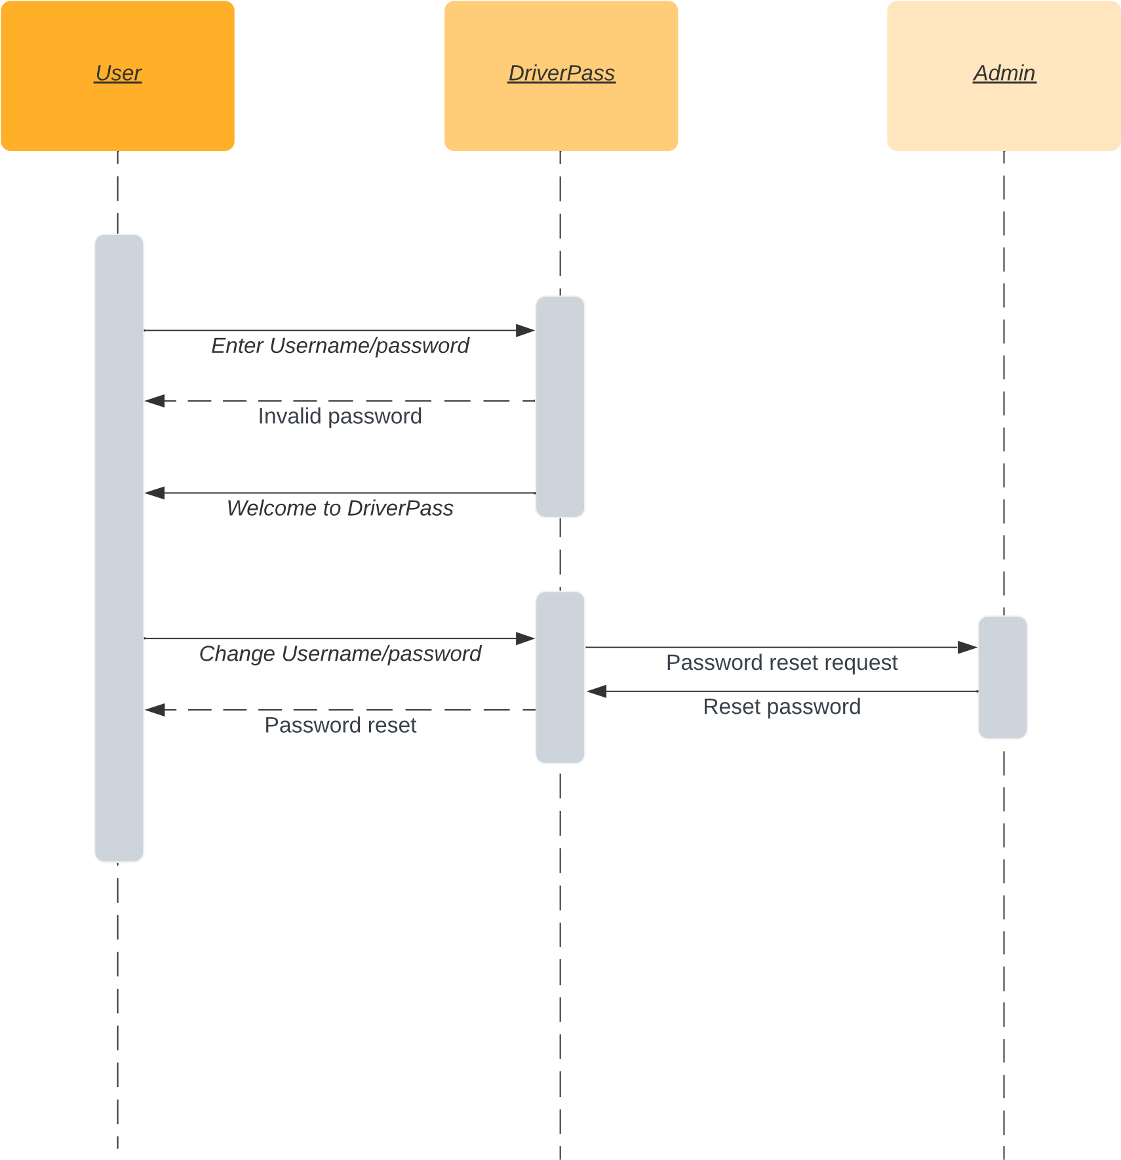

### UML Class Diagram

## Technical Requirements

The technical requirements necessary for this project are:

* Hardware: